**GasMenu Test Results (Failed & Resolved)**

**Ref#20: Amend Cost Per Unit ZERO**

Test 20 – Amend Cost Per Unit Zero

Option 1 : Create New Customer

Option 2 : Deposit An Amount

Option 3 : Enter Units Used

Option 4 : Display Balance

Option 5 : Display Full Account Details

Option 6 : Amend Discount

Option 7 : Amend Cost Per Unit

Option 8 : Help For User

Option 9 : Exit

Enter choice: 7

Enter New Cost Per Unit: 0

New Unit Cost £ 0.0 #####Failed####

**Coding In Menu**

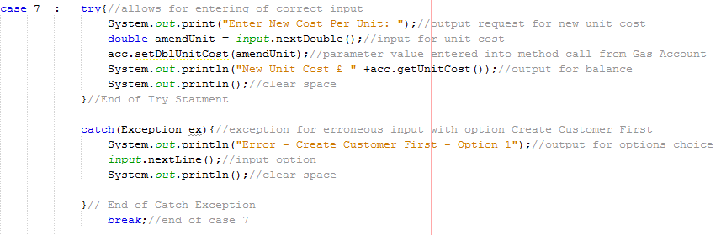

**Coding In GasAccount**

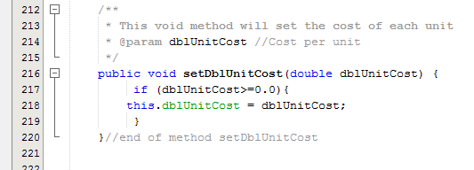

The mistake was in the if statement in the method setDblUnitCost. The condition was set to greater than (>) or equals to (=) this only needed to be greater than (>).

This has been rectified in code below.

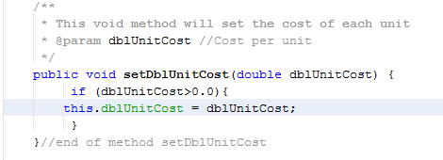

**Right Result Below**

*********Business Account************

*************************************

Option 1 : Create New Customer

Option 2 : Deposit An Amount

Option 3 : Enter Units Used

Option 4 : Display Balance

Option 5 : Display Full Account Details

Option 6 : Amend Discount

Option 7 : Amend Cost Per Unit

Option 8 : Help For User

Option 9 : Exit

Enter choice: 7

Enter New Cost Per Unit: 0.0

New Unit Cost £ 0.02